Steve Pantazis

**Assemblage Word Count 501**

Assemblage is an artistic form that involves the transformation of non-art objects into two-dimensional or three-dimensional artistic compositions. Together with abstraction, it has been considered one of the two most significant innovations of Modern art. The term *assemblage* was first used in 1953 by critic, philosopher and poet Max Loreau in describing French artist Jean Dubuffet’s series of imprint collages of butterflies’ wings. The term was popularised by the Museum of Modern Art’s 1961 exhibition *The Art of Assemblage,* which showcased the work of early twentieth-century European artists, such as Marcel Duchamp, Pablo Picasso, George Braque and Kurt Schwitters, and Americans such as Joseph Cornell, Man Ray and Robert Rauschenberg. The curator of the show William C. Seitz used the term assemblage to describe works where real objects and materials open up artistic possibilities and endeavour to bridge the gap between art and life. *Assemblage* is broader than the term *collage* as it refers also to three-dimensional and planar works; it is more specific than the word *construction* as it highlights the incorporation and accumulation of found objects such that they continue to remain visibly recognisable. In assemblage works, images and objects keep their connection with the everyday world from which they were taken and this connection gives the opportunity to the artists to work with a wide range of materials and techniques not originally intended to be used in art.

The ancestry of assemblage can be traced in Edgar Degas’ *Little Dancer Aged 14* (1880-81) –a bronze ballerina who wears a real muslin skirt and hair ribbon – in which the artist attempted to achieve greater realism. Assemblage emerged also in the circle of Cubists due to its association to collage. Picasso’s *Still-life* (1914), made from partly recycled and partly carved wooden elements and intended to be hung on the wall, represents his effort to move away from the painterly illusion. Schwitters and the other Dada artists used the technique to create works free from the illusionism of sculpture while Duchamp’s readymades have a similar anti-artistic intent, where little or no effort is required for the production of the components. The medium of assemblage was ideally suited to Surrealist practices as objects could be juxtaposed in their search for the marvellous. Meret Oppenheim covered a cup, saucer and spoon with fur in her work *Object* (1936), bringing together the bourgeois gentility with the feminine sexuality, a provocative move at the time. In the late 1950s and 1960s, the technique of assemblage became important for the transition from Abstract Expressionism to Pop and Minimal art and for the formation of new forms of artistic expression such as happenings and installation art.

**References and further reading**

Demetrion, J. T., ed. (1993) *James Dubuffet 1943 – 1963: Paintings, Sculptures, Assemblages: An Exhibition,* Washington, D.C.: Hirshhorn Museum and Sculpture Garden in association with the Smithsonian Institution Press.

Elderfield, J. ed. (1992) *Studies in Modern Art 2: Essays on Assemblage,* New York: The Museum of Modern Art.

Seitz, W. (1961) *The Art of Assemblage,* New York: The Museum of Modern Art.

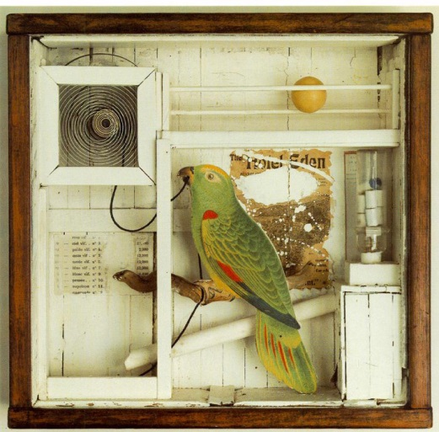

Joseph Cornell, *The Hotel Eden*, 1945.  
American, 1903 - 1972   
assemblage with music box  
38.3 x 39.7 x 12.1 cm  
Purchased 1973  
National Gallery of Canada (no. 17606)

[reproductions@gallery.ca](mailto:reproductions@gallery.ca)

<http://www.gallery.ca/en/image-reproduction/index.php>

<http://www.gallery.ca/en/see/collections/artwork.php?mkey=9425>